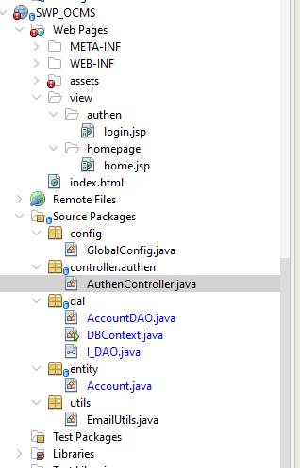

/*
* Click nbfs://nbhost/SystemFileSystem/Templates/Licenses/license-default.txt to change this license
* Click nbfs://nbhost/SystemFileSystem/Templates/Classes/Class.java to edit this template
*/
package dao;

import java.util.List;

/**
*
* @author ADMIN
* @param <T>
*/
public interface I_DAO<T> {

public List<T> findAll();

public T findById(T t);

public boolean update(T t);

public boolean delete(T t);

public int insert(T t);
}

